Team Dev Op Project Submission 1 – Outline
DoIT: A Team Task and Project Collaboration Platform

Angel Perez, Justin Emerick, Mathew Goncalves, and Daniel Nethala
Saint Leo University
COM 430: Software Engineering
Professor Paquette
May 17, 2026

Table of Contents
Cover Page 1
Table of Contents 2
Introduction and Purpose 3
Selected Application Enhancement 3
Six Thinking Hats 4
Roles and Responsibilities 6
Scope 7
Project Risks 8
Communication 10

Introduction and Purpose
The purpose of this group project is to design and develop DoIT: A Team Task and Project Collaboration Platform, a productivity application inspired by platforms such as Teams and Zoom. The application is intended to provide users with a centralized workspace where teams can communicate, organize tasks, manage projects, and collaborate in both academic and professional environments. As teamwork becomes more common in schools and workplaces, the need for organized communication and productivity tools continues to grow. DoIT aims to simplify collaboration by combining task management, project tracking, team communication, and meeting coordination into a single platform. Users will be able to join collaborative workspaces, assign tasks, monitor deadlines, and communicate with team members within the application.
Another major component of the project is the implementation of an AI-assisted productivity feature that helps users break larger goals into smaller and more manageable tasks. The AI assistant may also provide suggestions for task prioritization, project planning, and meeting organization to improve overall efficiency within teams.
From a software engineering perspective, this project allows the development team to apply concepts learned throughout the course, including software design, planning, testing, deployment, and documentation. The final product will serve as an enhanced collaboration platform while also demonstrating the team’s technical and collaborative development skills.
Selected Application Enhancement
The selected enhancements for DoIT: A Team Task and Project Collaboration Platform focus on improving communication, organization, and productivity within work and school environments. Since the application is designed to function similarly to platforms such as Microsoft Teams and Zoom, the goal of these enhancements is to create a more efficient and user-friendly experience that allows teams to manage projects, communicate, and organize tasks within a single platform.
One of the primary enhancements being added to the application is an AI-powered productivity assistant. This feature will allow users to enter assignments, project goals, or meeting objectives into the platform, and the AI assistant will generate smaller tasks, priorities, and recommended action steps. For example, if a user enters a task such as “Complete final history presentation,” the AI assistant may suggest subtasks including researching information, assigning roles, creating slides, reviewing, and rehearsing the presentation. This enhancement is intended to help users stay organized and improve project planning.
Additional enhancements include team collaboration and project management features that improve communication between users. The platform will include shared team workspaces where users can assign tasks, monitor deadlines, track project progress, and organize meetings within the application. These features are intended to improve collaboration and overall productivity for teams and organizations.
Overall, these enhancements were selected because they align closely with the purpose of DoIT while remaining realistic to develop within the project timeline. By combining communication tools, task management features, and AI-assisted productivity support, the platform aims to provide a modern and efficient collaboration experience for users.
Six Thinking Hats
White hat
Several ideas for an app were discussed during the meeting. The team has selected a project collaboration dashboard application. DoIT can be developed within 5-6 weeks. There will be different functionalities that this app will be able to do. Some features include shared workspaces, task management, reminders, collaboration tools, and an AI assistant.
Red hat
The team felt that this app will be interesting to create and will be finished within a limited amount of time. Also, this app is not too complex in which the given amount of time is suitable for the development of this application, which has allowed the team to believe that this app is a great choice.
Black hat
The team has assessed the risks associated with the development of this application. One risk identified is time constraints. Other risks include bug issues and errors during implementation that are involved with the development of this application. Also, an excessive number of features can prevent this app from being completed on time.
Yellow hat
The team has discovered that this app can be beneficial to users. One benefit in developing this application includes the ability for users to have a platform of communication, planning, and organization. An AI assistant will be beneficial for enhancing the platform’s efficiency. Several features of this system will be useful in managing tasks and meetings.
Green hat
Creative features such as advanced collaboration tools, productivity charts, a task tracker, and even a calendar feature are considered to enhance the application. However, not all features may be implemented due to time constraints.
Blue hat
The team discussed scheduling the development of this application. A timeline will be provided to organize the development of this application to be completed within a span of 5-6 weeks. Proper planning of this application will ensure that this application is completed on time and that this application will function properly.

Roles and Responsibilities
DoIT: Team and Project Collaboration Platform development team will consist of four people: Justin, Angel, Matthew and Daniel. The project will require responsibilities such as account manager, release manager, and tester (coding and documentation). Each member will take on a role based on the project requirements while continuing to collaborate throughout development. This structure will help the team stay organized and ensure all areas of the project are managed properly.
Daniel is going to be the Account Manager for the project. Responsibilities for this role will include managing communication between the team, organizing meetings, maintaining project information, and monitoring development progress. Tools for this role may include Slack, Teams, Google Docs, Jira, and email to support communication and collaboration throughout development.
Justin is going to be the Release Manager for the project. Responsibilities for this role include managing application versions, monitoring deployment, and ensuring that development remains organized throughout the project lifecycle. Justin will also assist with API integration, GitHub repositories, and deployment processes to help ensure the application functions properly during testing and development.
Angel is going to be the tester, which includes coding and documentation responsibilities for this project. Responsibilities will include implementing features, assisting with front-end development, managing GitHub branches, running tests, finding bugs, and organizing project documentation. These responsibilities will help ensure the application functions properly throughout development.
Although each member is assigned specific responsibilities, all team members will continue collaborating throughout development by assisting with coding, troubleshooting, testing, and project discussions when needed.
Scope
DoIT will be a project collaboration dashboard application which will help users and teams in managing tasks and projects. Users will be able to collaborate in shared workspaces and manage tasks in this application. Some features will include tools for teams and features to help users stay organized and complete tasks before deadlines. DoIT will provide teams tools for communication, task management, and project collaboration. The development timeframe for this project will take 5-6 weeks to complete. Optional features will be considered to enhance this application.
The following Work Breakdown Structure (WBS) outlines the major development phases and tasks associated with the DoIT project:
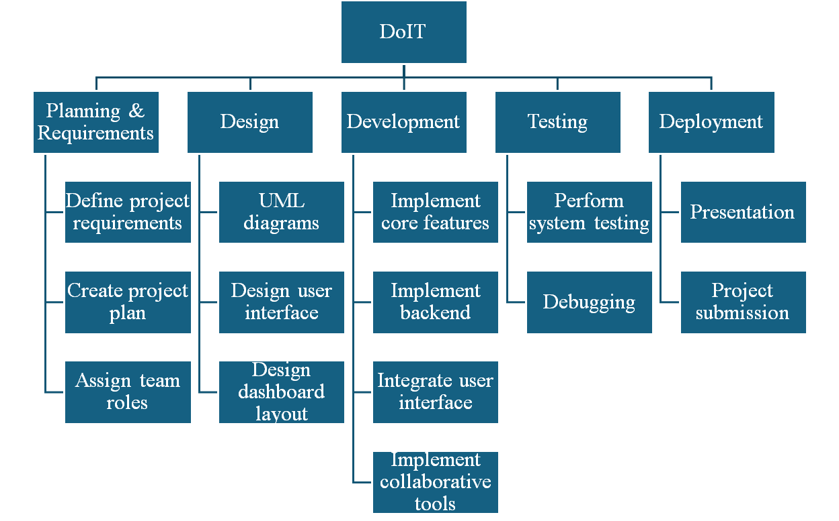
Estimated Schedule
Week 2 – Project Outline
Week 3 – Project Plan and design
Week 4 – Develop core features
Week 5 – Implement collaboration features, test application (version 1)
Week 6 – Test application (version 2), debug, and fix errors
Week 7 – Final testing and project submission
Week 8 – Present project

Project Risks
One of the primary risks associated with the development of the DoIT application is scope creep. As additional ideas and optional features are discussed throughout development, there is a possibility that the project could expand beyond the original timeline and development requirements. To reduce this risk, the team will prioritize core application functionality first and evaluate optional enhancements separately based on available development time and project progress.
Another potential risk involves uneven team participation or delays in completing assigned tasks, which could impact the overall development schedule and workflow. To help minimize this issue, the team will conduct regular progress meetings, maintain clear communication regarding responsibilities, and track milestone completion throughout the SDLC process.
Technical challenges and software bugs also present potential risks during implementation and testing phases. Since the application will contain multiple integrated features such as task management, collaboration tools, reminders, and shared workspaces, compatibility and functionality issues may arise during development. The team will reduce this risk through continuous testing, debugging, and version control practices using collaborative development tools such as GitHub.
In addition, deployment and integration challenges may occur if development tools, software environments, or collaborative features do not function as expected across all systems. To address this issue, the team will maintain organized project documentation, perform incremental testing throughout development, and regularly review feature integration during implementation.
The following table summarizes several key project risks, their potential impact, and mitigation strategies:

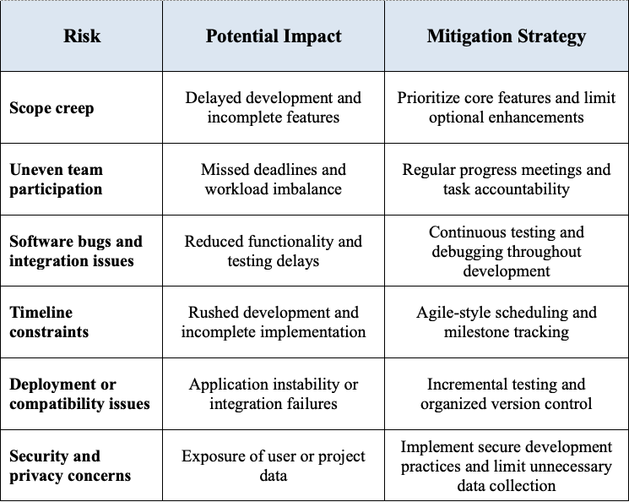
Communication
Effective communication will play an important role throughout the development of the DoIT application. The team will primarily use Microsoft Teams and group messaging channels to communicate, schedule meetings, share project updates, and discuss development progress. Regular meetings will be conducted to review completed tasks, identify technical issues, and assign new responsibilities as the project progresses. This communication structure will help ensure all team members remain informed and aligned throughout the SDLC process.
The team will also utilize collaborative development and documentation tools such as Microsoft Word, cloud storage, GitHub, and version control systems to manage project files and maintain organization. GitHub will allow team members to collaborate on development tasks while tracking project changes and reducing the likelihood of version conflicts during implementation.
In addition, the team will follow an Agile-inspired workflow by breaking development into smaller milestones while maintaining continuous communication regarding project goals, timelines, testing, and feature implementation. Team members will be encouraged to communicate blockers, delays, or technical concerns as early as possible, so issues can be addressed before impacting project progress.
Maintaining open communication, clearly defined responsibilities, and organized collaboration practices will help improve teamwork, reduce confusion, and support the successful completion of the DoIT application within the projected development timeline.

